**Challenge 3**

[www.pythonchallenge.com/pc/def/equality.html](http://www.pythonchallenge.com/pc/def/equality.html)

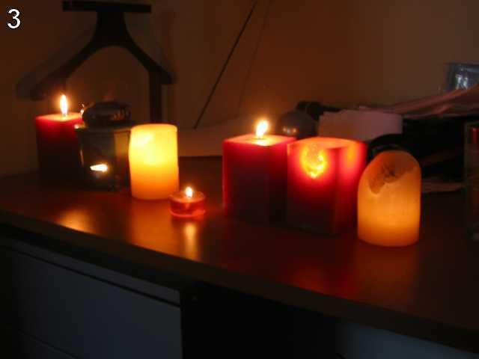  
One small letter, surrounded by **EXACTLY** three big bodyguards on each of its sides.

In the page source, there’s a bunch of letters small and capital. From the hint, the idea is to look for patterns like this xXXXxXXXx

The title of the page is ‘re’ so I’m guessing we should use the **re** module for this. I’m not great with **re** but practice doesn’t hurt. The result is a list of 10 of this pattern, and the middle (little) letter spelled out ‘linkedlist’. Plugging that into the url, unfortunately, it doesn’t go to the next challenge. But it is a webpage with just the message ‘linkedlist.php’. So, changing the .html to .php, we get to Challenge 4. 😊